**CICD Lab experiment 11 by Shrikant Lal**

**LAB-11**

1. Vagrant init command

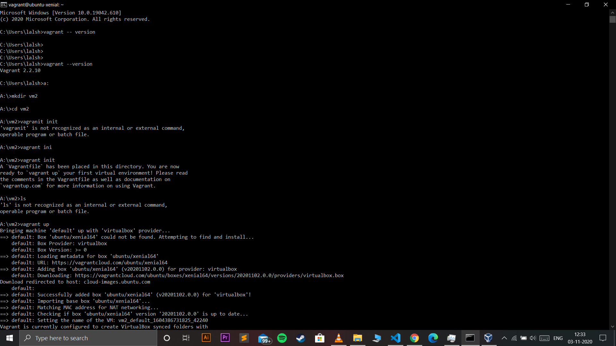

1. Changing vagrant file

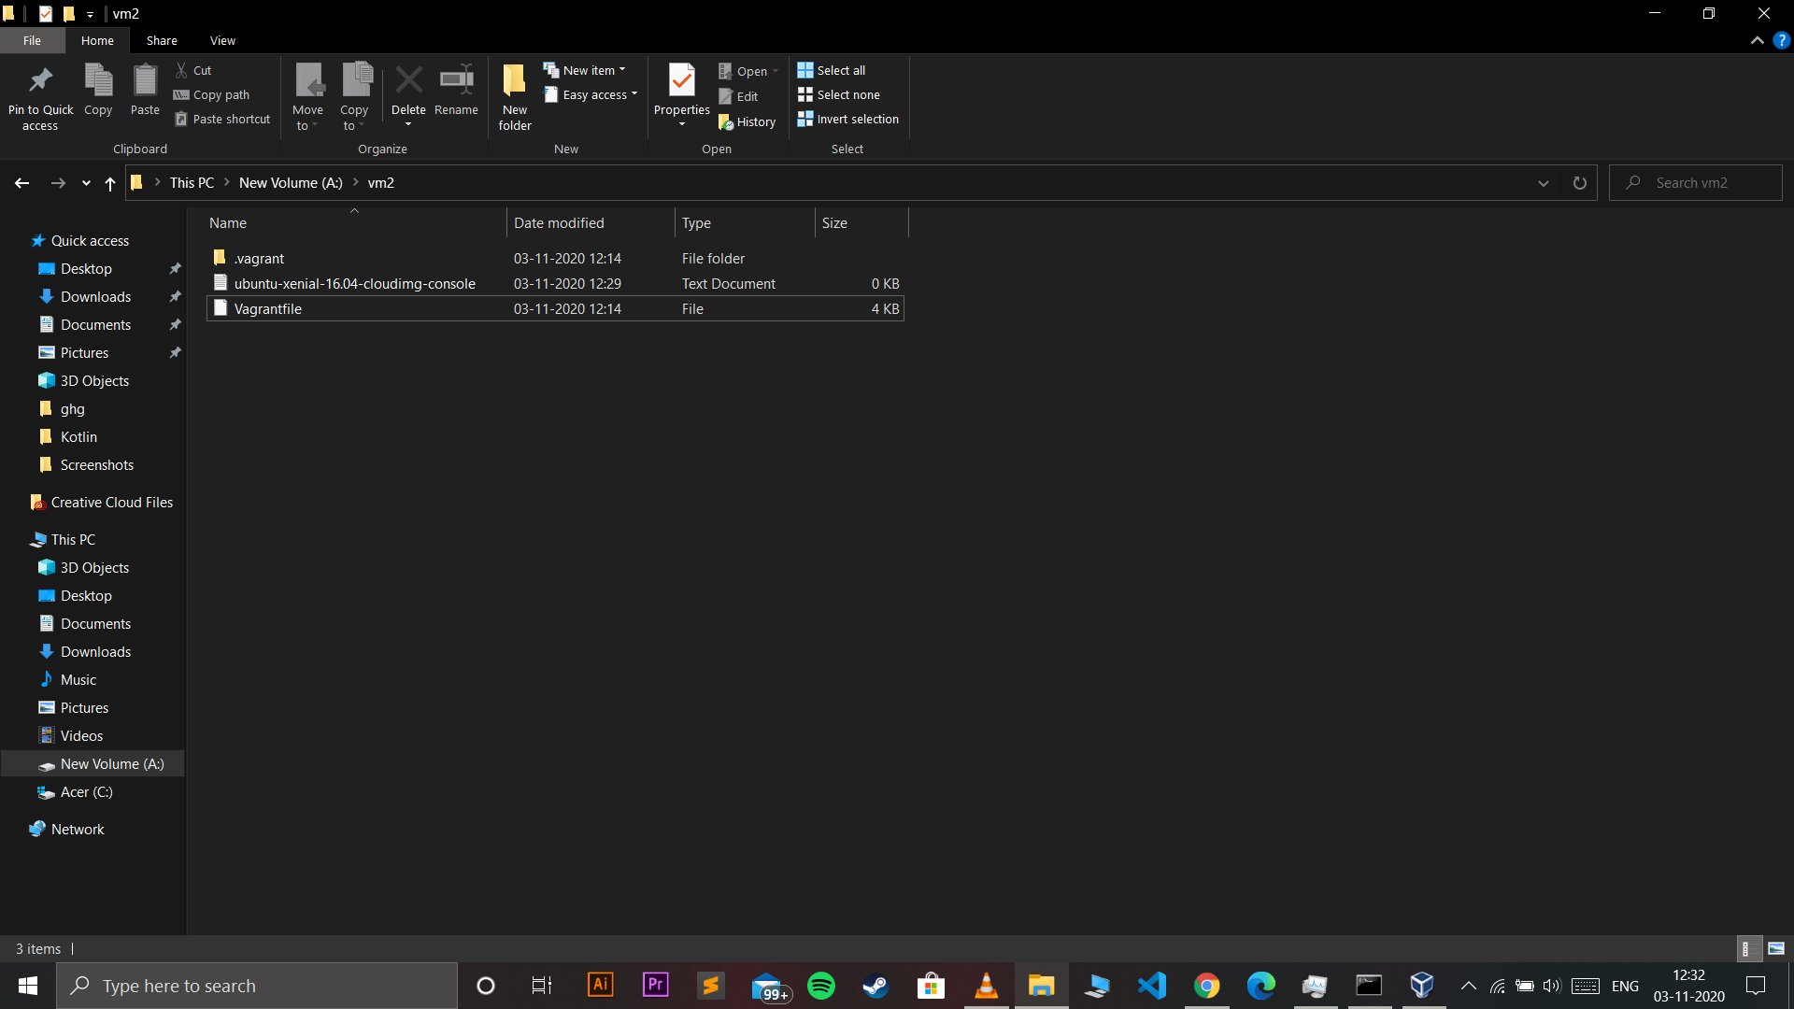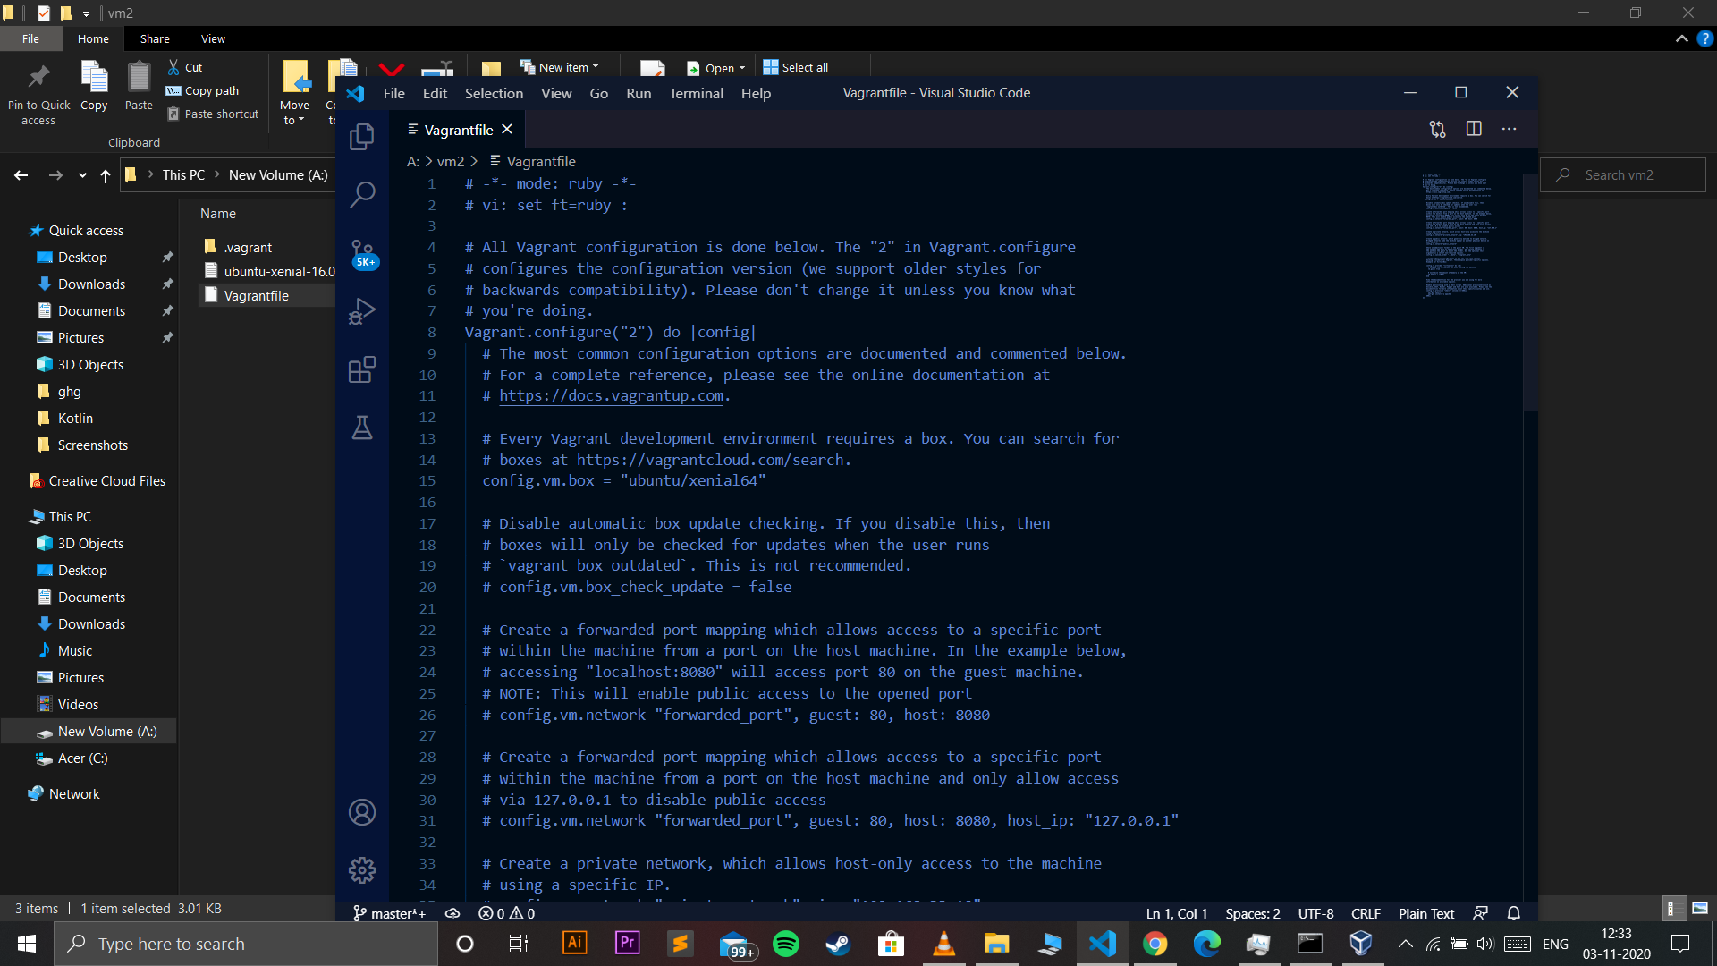

1. Running vagrant up command

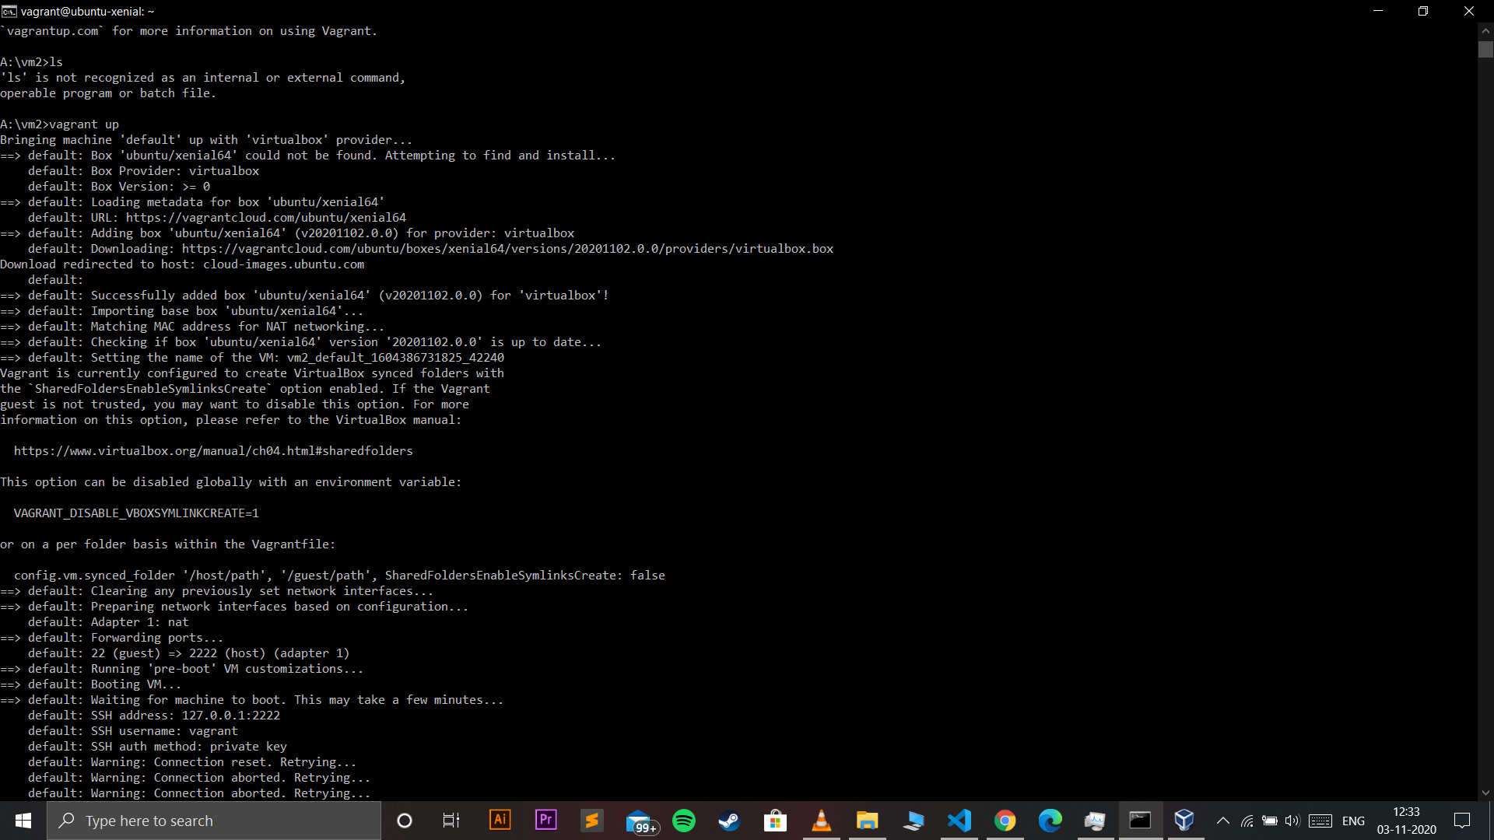

1. Runnung vagrant ssh command

